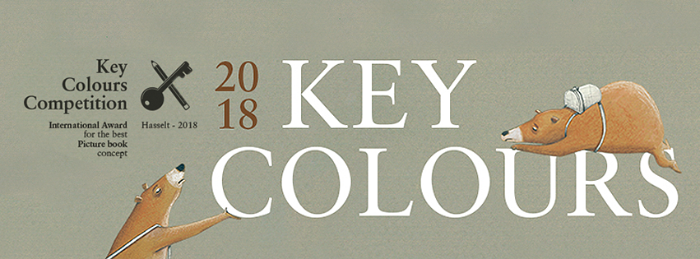

Jury Report Key Colours 2018

Key Colours is a contest for illustrators organized by the City of Hasselt and Clavis Publishing. The aim of the competition is to discover new talent for creating picture books. As traditionally, the submission for the competition consists of a picture book story, the sketches for this story and three final illustrations.
The 2018 edition of the Key Colours contest was a success. There were 423 entries from no less than 66 countries.

The jury of this year consisted of:
Ruth Wielockx, illustrator;
Francesca Pirrone, illustrator and winner Key Colours 2016;
Karolien Mondelaers, alderman of culture and education of the city of Hasselt;
Philippe Werck, publisher at Clavis Publishing.

The jury met on August 14, 2018. The following six nominees were unanimously chosen.

Nominated for Key Colours 2018 - Entry number 38
A Forgotten Sunday by Effie Lada from Athens (Greece)
It’s Sunday and it’s raining. The girl can’t play with her friends, so it will be a boring day. It’s even worse when the family is going to visit auntie. Until she starts telling fantastic stories. It suddenly becomes a great Sunday.
The illustrations have a strong natural look. Gray and dark clouds, the sadness of a gloomy Sunday are very expressive. The images become brighter and warmer when the aunt's stories come to life. A very nice balance between realism and atmosphere.

Nominated for Key Colours 2018 - Entry number 44
The Red Bird by Manuel Šumberac from Zagreb (Croatia)
In a futuristic environment we see a man and eggs, very special eggs. Some eggs come out. Blue birds, also a little futuristic, start living and flying. They demand all attention. Attention that is pulled away from that special egg, with that very special bird. You sometimes have to wait a long time before you find something special and unique.
A special way to express yourself. Futuristic, as we mentioned earlier. Almost mechanical, robotic, where man is small and almost insignificant in an open space without a clear situation. The special eggs, the special birds, all worked out in detail, hyper-realistic, but also very aesthetic and stimulating to look at.

Nominated for Key Colours 2018 - Entry number 174
Fido by Eva Schirdewahn from Flensburg (Germany)
A creature, an animal, not immediately to define what it is, looks with admiration at the dandelions, as if they are suns in the sky. But one doesn’t look like a sun, it is on the ground. The creature wants to do his very best to make this sun shine too, and to get the flower upright again. Impossible, everyone says, until he and the flower end up in the water. The flower still drinks and makes a fluff bulb.
Soft and sweet, how can you describe the figure, a little pig or a mouse? We are not completely out of it yet. But the images have a lovely atmosphere, realistic in their own reality. The images are also completely tuned to this story. Playful, changing perspective, narrating in itself on top of the story, as you see often in better picture books.

Nominated for Key Colours 2018 - Entry number 203
Bob's Journey by María Fernández de Córdova Miralles from Madrid (Spain)
An ink stain. A mistake by the illustrator, or the start of a story? The spot gets a red scarf, so we recognize him better. It becomes someone who makes a journey around the world, over mountains and seas, through big cities. The story of this ‘road trip’ is summarily in black and white, with only the red scarf to hold on to.
This illustrator loves drawing and details. Color is superfluous in this case. The stain becomes a traveler and he only lives on this paper, on which everything is shown two-dimensionally. He would perish in a world of color. Now he can lead his own life with his red scarf. The remarkable images caught the jury’s attention. The illustrator has found the right balance. Less is more.

Nominated for Key Colours 2018 - Entry number 279
Ana, ve a dormir a tu cama by Sara Casilda Campos from Toledo (Spain)
Many books are about going to bed. Probably because books are often read aloud in bed and because a bedtime story helps children to make the transition from a busy day to a nice dream. This book is a ‘going to bed’ book too. The main character doesn’t want to sleep in bed, but looks for all other possible and impossible places: the bath, the closet, even the lampshade. She is always disturbed by something or someone. The soft bed will eventually be the best place for a wonderful sleep.
The story shows a lot of fantasy, by allowing the main character to sleep in various unusual places. The accompanying images are refined and very realistic. If you see it, you might as well go to sleep on the lampshade, even if the relationship is unusual. It required some empathy, we suspect, to put it this way. And it worked out very well.

Nominated for Key Colours 2018 - Entry number 388
Helme’s big head by Ellen Lambrichts from Antwerp (Belgium)
The story starts with a presumable lonely boy. He looks back in his memory and seems happy with it. A memory of someone who is not with him now. So it is a love story. Maybe a bit grown-up, because the memories go back to the time they were together. And yet it’s a story of hope, there suddenly arrives a long awaited letter. A letter from her, out of his the memory.
This story has a special atmosphere because of the sober colors with almost exclusively red and blue. You feel the loneliness in the images, the expressions are a bit gloomy. This atmosphere is enhanced by many details that look like still life paintings. It gives the story a sort of distance: distance from the reader, who watches the memory in the character’s head. And yet we are sucked into the images and the story. A special and very successful combination of image and atmosphere.

